PROMISE & PRACTICE · DEEP DIVE · SOURCE ANALYSIS
John Brown & Harpers Ferry — House & Divided
Martyr or Madman?
Name: ______________________________ Period: _____ Date: ________________
WHAT I CAN DO TODAY I can read primary sources about John Brown & Harpers Ferry — House & Divided, weigh who made each one and why, and use evidence to answer historical questions.
Directions. Americans could not agree on John Brown then, and historians argue about him now. Weigh the evidence — two images and his own words — and reach your own verdict

THE SOURCES
SOURCE A · HOW HIS ENEMIES SAW HIM — “A Premature Movement”
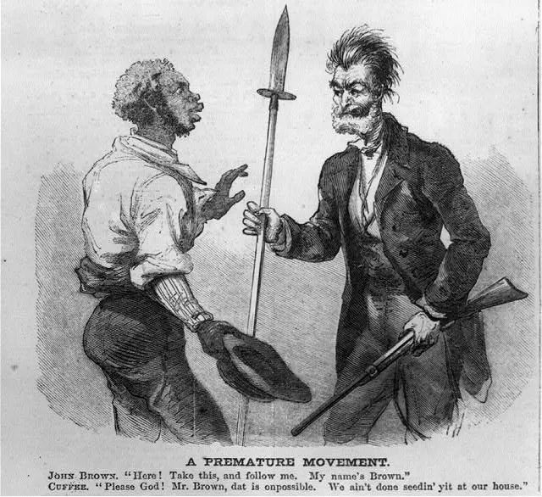
A hostile cartoon: Brown, wild-eyed, shoves a pike at an enslaved man who wants no part of it. The message — Brown was a dangerous fanatic forcing a fight nobody asked for
“A Premature Movement” — lithograph, c. 1859–60, public domain (Library of Congress).
SOURCE B · HOW HIS ADMIRERS SAW HIM — “Liberator of Kansas and Martyr of Virginia”
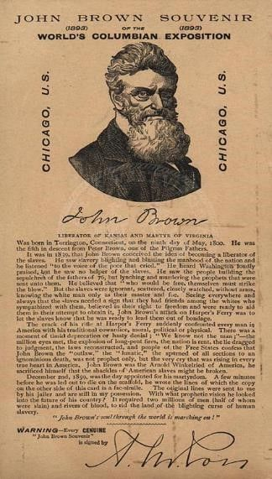
Decades later, this souvenir card honored Brown as a hero and “martyr” — a man who died for a holy cause
John Brown souvenir, World's Columbian Exposition, 1893, public domain. Collected image, © ShadowDog Digital Studios (SDS Digital Collection).
SOURCE C · BROWN IN HIS OWN WORDS · 1859 — At his sentencing
“Had I so interfered in behalf of the rich, the powerful … every man in this court would have deemed it an act worthy of reward rather than punishment. … Now, if it is deemed necessary that I should … mingle my blood … with the blood of millions in this slave country whose rights are disregarded by wicked, cruel, and unjust enactments, I say, let it be done.”
— John Brown, address to the court, November 1859. Public domain
— John Brown, address to the court, November 1859. Public domain.

YOUR WORK
QUESTION 1 STEP 1 · READ THE TWO IMAGES
Source A and Source B show the exact same person. What is each image trying to make you believe about John Brown? Name one detail in each that carries the message.
____________________________________________________________________________________________
____________________________________________________________________________________________
____________________________________________________________________________________________
____________________________________________________________________________________________
QUESTION 2 STEP 2 · HIS OWN DEFENSE
In Source C, what is Brown's main argument for why his actions were justified?
☐ A. that he didn't really break any law
☐ B. that the raid actually succeeded
☐ C. that acting for the enslaved is punished, while the same act for the powerful would be praised — so slavery is the true crime
☐ D. that he acted alone and regretted it
QUESTION 3 STEP 3 · YOUR INTERPRETATION
His cause — ending slavery — was just. His method — violence and armed insurrection — killed people and failed. Was John Brown a hero/martyr, a dangerous fanatic, or something in between? Take a position and defend it with at least one source (A, B, or C).
____________________________________________________________________________________________
____________________________________________________________________________________________
____________________________________________________________________________________________
____________________________________________________________________________________________
____________________________________________________________________________________________
QUESTION 4 STEP 3 · YOUR INTERPRETATION
Historians note that a person's reputation can change over time. Why might Brown be seen as a villain in 1859 but closer to a hero today? What changed?
____________________________________________________________________________________________
____________________________________________________________________________________________
____________________________________________________________________________________________
Promise & Practice · ShadowDog Digital Studios · Unit 2

TEACHER ANSWER KEY — John Brown & Harpers Ferry — House & Divided

QUESTION 1: Open response.
Look for a response along the lines of: “Source A wants me to see Brown as… (detail: …). Source B wants me to see him as… (detail: …).”
QUESTION 2: Correct — C. that acting for the enslaved is punished, while the same act for the powerful would be praised — so slavery is the true crime
Right. Brown argues that acting violently for the enslaved is treated as a crime, while the same act for the rich and powerful would be praised — so the real injustice is slavery itself, not his attempt to end it.
QUESTION 3: Open response.
Look for a response along the lines of: “I think John Brown was… My strongest evidence is…”
QUESTION 4: Open response.
Look for a response along the lines of: “Views of Brown changed because…”

